Chapter 3: Building a Sign-Up and Login Webpage with Data Integration from Firebase
General Overview
In this final chapter, we aim to build a complete sign-up and login webpage that allows users to create accounts and then log in to access specific data. This chapter's primary focus is integrating the Firebase cloud service with a custom-built web application. By creating an authenticated user system, we can ensure that only authorized users can view sensitive data, adding a layer of security to our IoT project. The chapter is divided into two main sections: building the sign-up and login webpage and integrating Firebase data into the webpage.
1. Building the Sign-Up and Login Webpage
To create a functional sign-up and login webpage, we need both a front-end and a back-end. Here's the process for building each component.
1-1. Front-End Development
The front-end represents the user interface that visitors interact with on the website. We used the following technologies to build it:
- HTML and CSS: These foundational languages define the structure and styling of the webpage. HTML is used for the page's content and layout, while CSS provides design and styling.
- Bootstrap Framework: This framework helps create responsive and visually appealing webpages. It offers a wide range of pre-designed components, simplifying the front-end development process.
The front-end consists of two key pages: the sign-up page and the login page.
- Sign-Up Page: This page allows users to create an account. It contains fields for entering personal information like username, email, and password, with validation to ensure proper data entry.
- Login Page: This page is for existing users to log in to their accounts. It includes fields for username/email and password, with a "Remember Me" option for persistent sessions.
1-2. Back-End Development
The back-end handles the server-side logic, database connections, and security. We used these technologies to build the back-end:
- PHP and MySQL: PHP is a server-side scripting language used to process data and interact with databases. MySQL is a relational database management system to store user information.
- XAMPP and Apache Server: XAMPP is a software package that provides an Apache server, MySQL, and PHP, creating a local development environment. Apache handles HTTP requests and serves the webpage.
- phpMyAdmin: This web-based platform allows for easy management of MySQL databases. It was used to set up the database for user authentication.
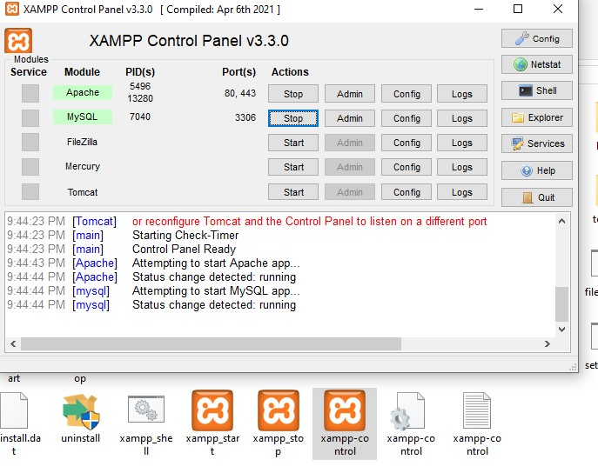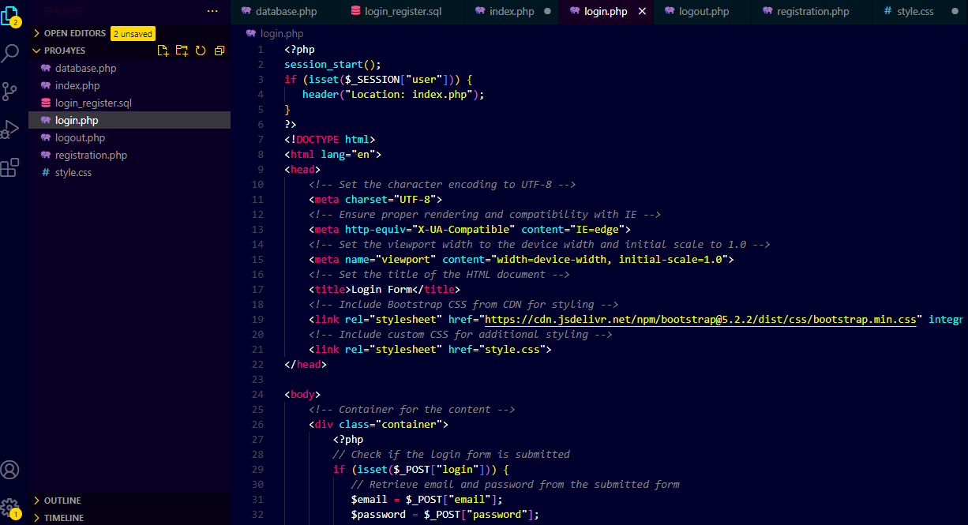
Figure 1 : XAMPP control panel :activating Apache and MySQL

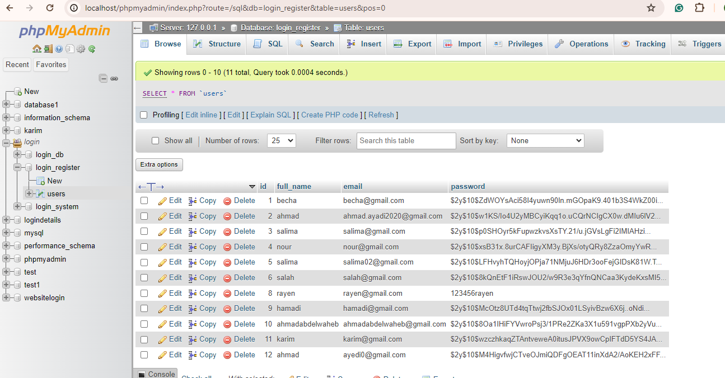
Figure 2 : phpMyAdmin :managing MySQL Database Operations
Back-End Logic: In the back-end, PHP scripts manage the server-side logic, including user registration, login, and session management. The MySQL database stores user information, like usernames, emails, and hashed passwords.
- Sign-Up Process: When a user submits the sign-up form, the PHP script validates the input and checks if the username/email is already in use. If valid, the information is stored in the MySQL database, and the user is redirected to the login page.
- Login Process: When a user logs in, the PHP script verifies the username/email and password against the database. If valid, a session is created, allowing the user to access restricted pages.
1-3. Adding Authentication and Security
To ensure security, the following measures were implemented:
- Password Hashing: User passwords are hashed before storing them in the MySQL database, preventing plaintext storage and enhancing security.
- Session Management: PHP sessions maintain user login status, allowing users to remain logged in across multiple page visits.
- Secure Connections: HTTPS is used to encrypt data transmitted between the browser and the server, preventing eavesdropping.
2. Integrating Firebase Data into the Login Webpage
After building the sign-up and login webpage, the next step is to integrate data from Firebase into the back-end. This process involves retrieving temperature data stored in Firebase and displaying it on the webpage when an authenticated user logs in. Here's how we achieved this integration.

Figure 3 : Firebase-Django Connection
2-1. Reading Data from ESP32 and Sending to Firebase
First, we collect temperature data from a DHT11 sensor using the ESP32 microcontroller. The ESP32 connects to Firebase and sends the temperature data to the cloud in real time. This setup allows data to be stored in Firebase, where it can be accessed from anywhere.
- ESP32-Firebase Connection: The ESP32 connects to Firebase using appropriate credentials. The Arduino IDE code establishes this connection and sends temperature data to Firebase.
- Firebase Real-Time Database: The temperature data is stored in the Firebase real-time database, allowing for continuous updates and immediate data retrieval.
2-2. Retrieving Data from Firebase with Python and Django
Next, we use Python with the Django framework to retrieve temperature data from Firebase. The goal is to send this data to the back-end of our login webpage so that authenticated users can view it upon logging in.
- Python-Django Framework: Django is a high-level Python web framework that simplifies building robust back-ends. It provides tools for database interaction and web server communication.
- Firebase-Django Connection: Python code using Django is written to connect to Firebase, retrieve the stored temperature data, and process it for the login webpage's back-end.
- Data Transmission: The Django-based code retrieves data from Firebase and sends it to the PHP back-end, allowing the login webpage to display the temperature data when a user logs in.
2-3. Displaying Data on the Webpage
Once the temperature data is retrieved from Firebase, we integrate it into the PHP back-end of our login webpage. This step involves modifying the PHP code to receive data from Django and display it on the page.
- Updating the Login Webpage: The login page is updated to display the temperature data instead of a generic "Welcome" message. This change allows authenticated users to view real-time data on their personalized webpage.
- Secure Data Transmission: The PHP back-end ensures that data transmission is secure, with proper authentication and session management to protect sensitive information.
3. Building a User Interface for Data Visualization
To enhance the user experience, we create a simple interface for visualizing temperature data. The goal is to provide a clear and intuitive way for users to view their data upon logging in.
- Data Visualization: The front-end is updated with simple visual elements to display temperature data in a user-friendly format. This could include graphs, tables, or real-time temperature readings.
- User-Friendly Design: By integrating Bootstrap, we ensure the webpage is visually appealing and responsive, allowing users to access it from different devices.
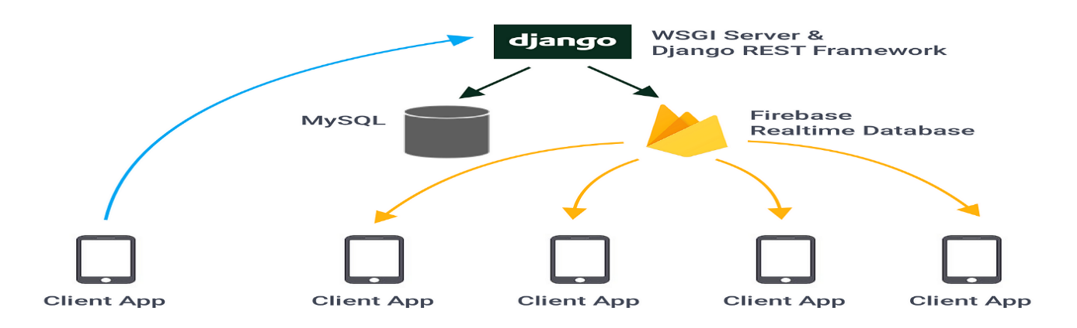
Figure 4 : Back-end Architecture with Django,Firebase, and MySQl
4. Conclusion
In this chapter, we built a complete sign-up and login webpage, allowing users to create accounts and access personalized data upon logging in. We achieved this by integrating Firebase with the PHP back-end and retrieving data from the cloud through Python and Django. By sending temperature data from ESP32 to Firebase and then retrieving it to the back-end, authenticated users could access real-time data on their webpage.
This chapter demonstrated the importance of combining various fields, including web development, cloud computing, servers, networking, and embedded systems, into a cohesive project. The integration of Firebase, PHP, Django, and ESP32 allowed us to create a robust and secure system, showcasing the potential of modern technology in IoT projects. By exploring these different domains, we gained valuable experience and insights into how these technologies interact, enabling us to build comprehensive and scalable solutions.

